**Quick Start Guide**

**GoVision**

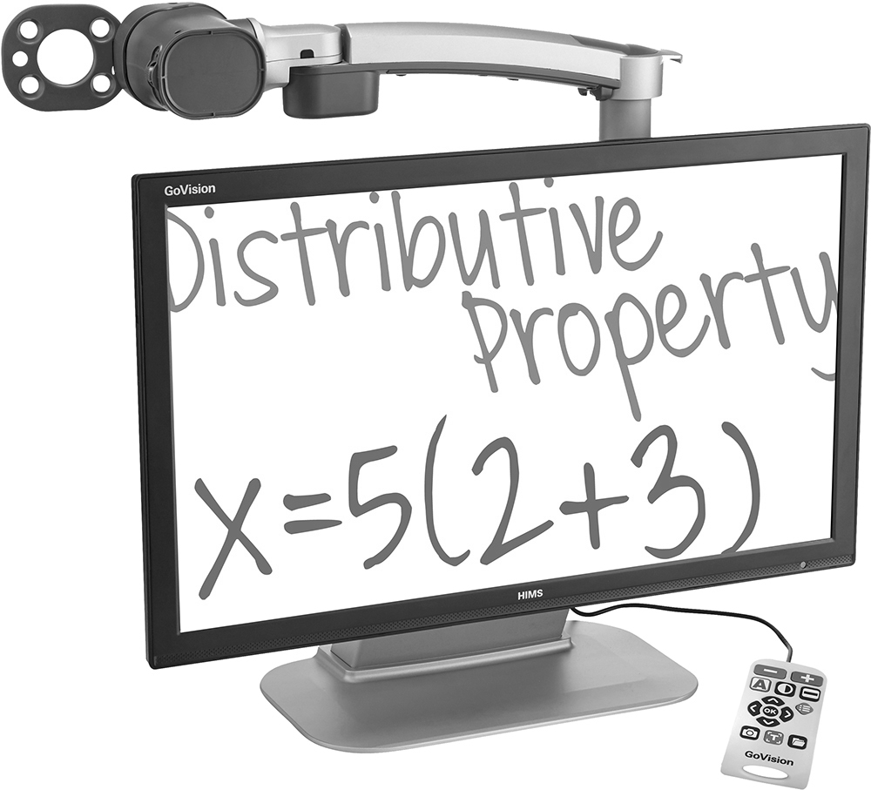



Introduction

This quick guide manual describes the features and functions of the HIMS GoVision transportable electronic magnifier. Please read this manual thoroughly before using your GoVision, and keep it in a safe place for easy access should you need to refer to it at a later time.

This User’s guide also includes product warranty information and safety precautions. If there are any updates to the GoVision specifications or features, this manual will be updated to reflect these changes and placed on the GoVision section of the www.hims-inc.com website.

**Copyright**

GoVision products and intellectual property, including documentation copyrights, are protected by copyright laws, with copyright belonging to JAWON Medical CO., LTD. and HIMS Inc., and may not be used without expressed permission from JAWON Medical CO., LTD. This User Guide may not be copied in whole or part, without permission.

JAWON Medical is the developer and manufacturer of all HIMS brand products for the blind and visually impaired. JAWON Medical is the parent company of HIMS Inc., a wholly-owned subsidiary based in Austin, TX.

Copyright ⓒ 2016 JAWON MEDICAL CO., LTD.   
All rights reserved.

# Safety Precautions

To ensure your personal safety and the proper use of the product as well as to prevent accidental damage, please be aware of and abide by the following safety precautions.

## WARNING! For Your Safety

Failing to follow the below precautions may cause serious injury or death.

* Do not attempt to disassemble or repair the product yourself. Only authorized repair technicians should disassemble or repair the GoVision, Unauthorized disassembly or repair of the GoVision will void the warranty of the product.
* Handle the GoVision with care, as it contains delicate parts. Damage caused by dropping, or external force or shock is not covered by the warranty.
* Please keep the GoVision away from extreme temperatures or humid conditions. Do not use the GoVision in environments above 104 degrees Fahrenheit (40 degrees Celsius) or lower than minus 50 degrees Fahrenheit (10 degrees Celsius).
* Do not connect the GoVision to ANY electronic devices not indicated in this manual.
* Do not use excessive force when adjusting the camera and camera arm.
* Install the product on a flat, level surface.
* Keep GoVision and its accessories away from infants, small children or pets.

## Safety Precautions

Failing to follow the precautions marked with this sign, may result in personal injury or property damage.

* Do not use loose power outlets, or a damaged power connector or cord.
* Do not touch the product, the power connectors, or a wall outlet with wet hands.
* Do not plug multiple power devices into the same outlet as GoVision.
* Do not bend or pull the cord to move the unit.
* Use only the power supply provided with the product by the manufacturer, or a power supply meeting the electrical specifications provided by the company.
* Please keep GoVision away from hazardous or flammable substances.
* Always consult our service personnel or an electrician before using an adapter that did not come with the product.

# Product Information

## Package Contents

Please ensure all of the following items are included in your packing box. If any items are missing, please contact the dealer from whom you purchased the product.

|  |
| --- |
| 지시 Note |
| Content may differ slightly from the actual components, as items are subject to change without prior notice to improve the quality of the product. |

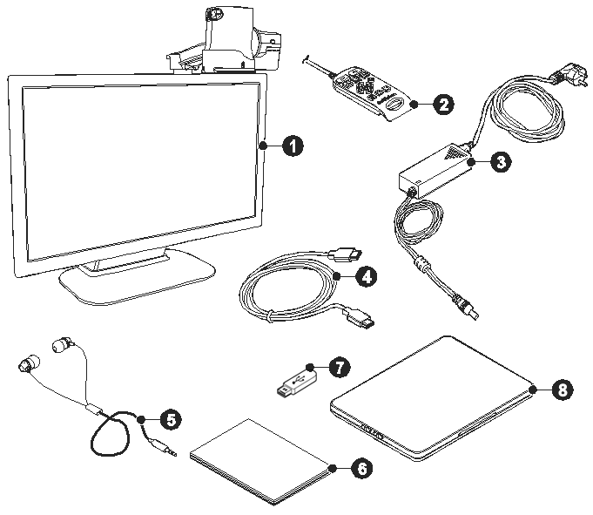

|  |  |
| --- | --- |
| Number | Name |
|  | GoVision |
|  | Remote control |
|  | Power adapter |
|  | HDMI cable |
|  | Headphone |
|  | Quick start guide |
|  | USB memory |
|  | Optional X/Y moving table |

## Physical Orientation

Please take a moment to familiarize yourself with the various parts and controls of the GoVision.

### Front Face

Main_front

|  |  |
| --- | --- |
| Number | Name |
|  | Jog Switch |
|  | Near View Mode Lens |
|  | Monitor |
|  | Power Switch |
|  | Camera Arm |
|  | Camera Connector |
|  | Camera |

### Back Face

Main_rear

|  |  |
| --- | --- |
| Number | Name |
| ① | Remote Control Holder |
| ② | Lock Lever |
| ③ | Remote Control Port |
| ④ | Power Port |
| ⑤ | HDMI Port |
| ⑥ | USB Port |

# Set up GoVision

## Powering Up

|  |
| --- |
| 1. Connect the power adapter to the power port on the back of the product. |
| Power1 |
| 1. Connect the power cord to a wall outlet. |
| Power2 |

## Remote Control Setup

|  |
| --- |
| Connect the end of the remote control's cable to the Remote Port on the back of the GoVision. The remote control is ready to use. |
| Contoller |

## Connecting Headphones

It may be advantageous to use earphones in noisy environments or in environments where you do not wish to disturb those around you.

|  |
| --- |
| Connect the earphone to the headphone jack located on the right side of the top of the remote control. |
| Earphone |

# Basic Functions

### Power ON / OFF

|  |
| --- |
| 1. Press and hold the Power button for more than 3 seconds. |
| Power_on |
| 1. The standby screen appears, then the unit powers on. |
| loading image_01 |
| 1. To turn the power off, press the Power button again for more than 3 seconds. |

## Camera Setup

|  |
| --- |
| 1. Place the lock lever in the horizontal position. |
| 설치_카메라 조정_01 |
| 1. Pull up on the camera arm to adjust the height. |
| 설치_카메라 조정_02 |

|  |
| --- |
| 1. Return the lock lever back to the vertical position. |
| 설치_카메라 조정_03 |
| 1. Adjust the location of the camera by rotating the camera arm. |
| 설치_카메라 조정_04 |

|  |
| --- |
| 1. You may move the camera left, right, up or down. |
| 카메라 넥 좌우 회전카메라 좌우 회전 |

### Using Near View Mode

Use Near View to read or view things at close range, such assigning a check or viewing a photo.

|  |
| --- |
| 1. Rotate the camera arm so that the camera faces the front of the product. |
| Camera_close1 |

|  |
| --- |
| 1. Make sure the camera is pointed downward. |
| Camera_close2_수정 |
| 1. Ensure the Near View lens is closed. |
| Camera_close3 |

### Using Distance View Mode

Use when viewing distant objects, such as a blackboard in a classroom.

|  |
| --- |
| 1. Rotate the camera arm so that it faces the back of the product. |
| Camera_long1 |
| 1. Point the camera so that it is facing the distant target. |
| Camera_long2 |

|  |
| --- |
| 1. Open the Near View lens. |
| Camera_long3 |

### Using Self View Mode

Use as a mirror with the added benefit of magnification when applying makeup or performing other facial grooming.

|  |
| --- |
| 지시 Note |
| The maximum distance for Self View Mode is 45 cm from the camera. Keep in mind that images further than that distance will likely appear out of focus. |

|  |
| --- |
| 1. Rotate the camera so that it is facing the front of the product. |
| Camera_close1 |
| 1. Point the camera toward your face. |
| Camera_self |

## Set LED

|  |
| --- |
| 지시 Note |
| This setting applies only in in Near View Mode. LED Lights turn off automatically when switching to Distance View Mode or Self View mode. |

### LED ON/OFF

|  |
| --- |
| 1. Press and hold the center of the Jog Switch for more than 2 seconds. |
| Light_jogswitch1 Light_jogswitch2 |
| 1. Each time you press this command, it toggles the LED on and off. |

## Using the Remote Control

컨트롤러

|  |  |  |
| --- | --- | --- |
| Order | Button | Function |
| ① | 컨트롤러_화면 배율 조정 | Increase and Decrease Magnification |
| ② | 컨트롤러_화면 색상 변경 | Adjust Color Mode |
| ③ | 컨트롤러_화면 명도 대비 조절 | Contrast Adjustment |
| ④ | 컨트롤러_상하좌우 이동 | Move Up, Down, Left, and Right |
| ⑤ | 컨트롤러_선택 | Select |
| ⑥ | 컨트롤러_화면 캡처 | FREEZE |
| ⑦ | 컨트롤러_OCR 기능 | Execute OCR (optical character recognition) |
| ⑧ | 컨트롤러_파일 탐색기 | File Browser |
| ⑨ | 컨트롤러_사용자 환경 설정 | Menu, to set User Preferences |
| ⑩ | 컨트롤러_마커 기능 | Set Marker |

# Advanced Functions

## User Preferences

You can use the menu to customize many of the features of GoVision.

|  |
| --- |
| To open the menu, press [컨트롤러_사용자 환경 설정] on the remote control. |
| 컨트롤러 사용_환경설정_작은이미지 |

#### Selecting Options

|  |  |
| --- | --- |
| Button | Functions |
| 컨트롤러_선택 | 1. Activate the current menu item 2. 이미지 6 Toggle a check box |
| 컨트롤러_좌 or 컨트롤러_우 | 1. Enter or Exit menu 2. Adjust the value of the current setting |
| 컨트롤러_상 or 컨트롤러_하 | 1. Move among menu and list items |

#### Menu Items

|  |  |  |
| --- | --- | --- |
| Order | Items | |
| 1 | Light | |
| 2 | Focus Lock | |
| 3 | OCR Language | |
| 4 | Digital Photo Frame | |
| 5 | Digital Clock | |
| 6 | Advanced options | Color Mode Settings |
| Marker Settings |
| Voice Settings |
| OCR Settings |
| Language Settings |
| Digital Photo Frame Settings |
| Digital Clock Settings |
| Screen Saver settings |
| Camera Frequency |
| My Settings |
| Initialization |
| Product Information |

## 

## Screen Magnification

### Increase and Decrease Magnification

You can adjust the screen magnification in 68 increments.

|  |
| --- |
| 1. Press [컨트롤러_확대] to increase magnification, and [컨트롤러_축소] decrease it. |
| 컨트롤러 사용_확대_축소 |
| 1. The current level is displayed on the screen. |
| 32p en 사본 |

## Check current Reading Position

|  |
| --- |
| 1. Press and hold [컨트롤러_화면 배율 조정] simultaneously. |
| 컨트롤러 사용_확대_축소 |
| 1. The document is reduced to normal size, and your current position is marked with a cross shape [ + ]. |
| 34p en 사본 |
| 1. Release the Zoom buttons and you are returned to your previous position and magnification level. |

## Color Mode

|  |
| --- |
| 지시 Note |
| In addition to changing the general color modes, you can use the menu to define 4 of the color modes with text and background colors of your choosing. |

Cycle through the enabled color modes.

|  |
| --- |
| To change the Color Mode on the current screen, press [컨트롤러_화면 색상 변경] |
| 컨트롤러 사용_색상변경 |

## Contrast Control

Due to variations in paper type, text type and color and the background color of documents or books that you are reading, you may need to adjust the contrast from 1 to 40 steps to read the documents or books clearly.

|  |
| --- |
| 1. Press [컨트롤러_화면 명도 대비 조절] on the remote control. |
| 컨트롤러 사용_명도 대비 조절 |
| 1. To increase contrast press [컨트롤러_우]. To decrease contrast press [컨트롤러_좌]. |
| 컨트롤러 사용_좌우이동 |
| 1. To save the contrast setting, press [컨트롤러_선택]. |

|  |
| --- |
| 지시 Note |
| To adjust the contrast, press and hold [컨트롤러_화면 명도 대비 조절] while pressing [컨트롤러_확대] or [컨트롤러_축소] on the remote control |

## Markers

Markers help you to focus on the text that you are reading by narrowing the display area with window markers or by underlining the sentence that you are reading.

|  |
| --- |
| Use [컨트롤러_마커 기능] on the remote control to cycle through the available markers: **[Horizontal Line Marker]**, **[Vertical Line Marker]**, **[Horizontal Window Marker]** and **[Vertical Window Marker]**. |
| 컨트롤러 사용_마커 기능 |

## Screen Capture

To display a still image for a closer look at the content, or to save an image for later viewing, you can capture an image and save the content to a USB flash drive.

### Screen Capture

|  |
| --- |
| 1. Press the [컨트롤러_화면 캡처], and the current image is frozen on the screen [프리즈] and a camera snapshot sound is heard. |
| 컨트롤러 사용_화면 캡쳐 |

|  |
| --- |
| 1. When the image is frozen, you may adjust magnification or color modes, just as with the live view. |
| 43p_en 사본 |
| 1. To return to live viewing, press [컨트롤러_화면 캡처] again. |

### Saving a Still Image

|  |
| --- |
| 1. Connect the USB cable to the USB port on the back of the product. |
| USB |
| 1. When the image is frozen, press and hold [컨트롤러_화면 캡처] for more than 2 seconds. |
|  |
| 1. When “Save photo done” [i_192x192_1] is displayed and spoken, the image is saved to the USB drive. |

|  |
| --- |
| 지시 Note |
| If the USB drive is not connected correctly, the message "Save file failed" is displayed on the screen. The image is saved to the USB as /GoVision/Image/MMDDYYYYhhmm.png. |

## OCR (Optical Character Recognition)

OCR allows you to read text material aloud using the built-in text-to-speech.

|  |
| --- |
| 1. When the document is displayed on the monitor, press [컨트롤러_OCR 기능]. |
| 컨트롤러 사용_OCR 기능 |
| 1. The text of the document is analyzed and begins reading aloud. |
| 1. Use **[**컨트롤러_좌**]** or **[**컨트롤러_우**]** to read the next and previous sentence, use the **[**컨트롤러_상**]** or **[**컨트롤러_하**]** to move by paragraph. |
| 1. Press [컨트롤러_선택] while reading and playback is paused, pressing [컨트롤러_선택] again resumes reading. |
| 1. To exit the OCR function, press [컨트롤러_OCR 기능] |

## 

## File Viewer

You can use the File Viewer to view saved images, OCR scans, videos, or text-based files.

### Connect the USB

|  |
| --- |
| 1. Connect the USB cable to the USB port on the back of the product. |
| USB |
| 1. Press [컨트롤러_파일 탐색기] on the remote control. |
| 컨트롤러 사용_파일 탐색 기능 |
| 1. Image, video, and document files and folders appear on the screen. |
| 1. Use [컨트롤러_상] or [컨트롤러_하] to navigate to your desired file, then press [컨트롤러_선택]. |
| 1. To close the document, press [컨트롤러_파일 탐색기]. |

#### Document View Setting

|  |  |
| --- | --- |
| Button | Function |
| 컨트롤러_화면 배율 조정 | Increase and Decrease Magnification |
| 컨트롤러_화면 색상 변경 | Change Color Mode |
| Press [컨트롤러_상] or [컨트롤러_하] | Navigate by line |
| Press [컨트롤러_상] or [컨트롤러_하] twice in quick succession | Navigate by page |

#### Supported file formats

|  |  |
| --- | --- |
| Option | Format |
| Document | MS Word 97~2014 (.doc, .docx, .dot, .dotx),  HWP 97~3.0, 2002~2014 (.hwp),  Text (.txt, .asc), Rich Text (.rtf) |
| Image | PNG, BMP, JPG(JPEG) |
| Video(Codec) | H.263, H.264 AVC |
| Subtitle | smi, srt |

## Voice Guide

You can adjust speed, volume and pitch of the voice guide as well as turn it on and off.

|  |
| --- |
| 1. Press [컨트롤러_사용자 환경 설정] on the remote control and select [Advanced Options]. |
| 1. Select [Voice Attribute Setting], then press [컨트롤러_선택] or [컨트롤러_우]. |
| 73 |
| 1. Select [Voice Guide], then press [컨트롤러_선택] or [컨트롤러_우]. |
| 73 |

## Focus Lock

If there is movement in the camera view, such as when you are writing under it, you may wish to lock the focus so that it doesn't try to follow your hand or pen.

|  |
| --- |
| 1. Press [컨트롤러_사용자 환경 설정] on the remote control. |
| 1. Select [Focus Lock], then press [컨트롤러_선택] or [컨트롤러_우]. |
| 75 |
| 1. The lock symbol [E-bot Focus-03-1] appears on the screen. |
| 76 en 사본 |
| 1. To turn off, Focus Lock, press [컨트롤러_선택] or [컨트롤러_우]. The lock symbol [E-bot Focus-03-1] disappears. |

# Add-Ons

## Digital Photo Frames

You can view images on a USB drive on GoVision's monitor as a slide show.

|  |
| --- |
| 지시 Note |
| The first time you connect a USB drive to the product, a [GoVision] folder is automatically created. If the folder does not exist, disconnect and reconnect the USB drive. |

### Digital Frame Playback

|  |
| --- |
| 1. Save the images in the [Slide] folder of the [GoVision] folder on the USB drive. |
| 1. Connect the drive containing the photos to the USB port on the back of the product. |
| USB |
| 1. Press [컨트롤러_사용자 환경 설정] on the remote control. |
| 1. Select [Digital Photo Frame], then press [컨트롤러_선택] or [컨트롤러_우]. |
| 1. Pictures in the [GoVision] folder are sequentially displayed on the monitor. |

|  |
| --- |
| 지시 Note |
| Press [컨트롤러_OCR 기능] and [컨트롤러_파일 탐색기] simultaneously to start and stop the Digital Photo Frame. |

## Digital Clock

While using GoVision, you can easily check the time with the full-screen digital clock.

|  |
| --- |
| 지시 Note |
| Press [컨트롤러_OCR 기능] and [컨트롤러_화면 캡처] simultaneously and the Digital Clock appears on the screen. |

### Digital Clock Display

|  |
| --- |
| 1. Press [컨트롤러_사용자 환경 설정] on the remote control. |
| 1. Select [Digital Clock], then press [컨트롤러_선택] or [컨트롤러_우]. |
| 80 |
| 1. To return to the previous screen, press [컨트롤러_사용자 환경 설정] or [컨트롤러_좌]. |

## Screen Savers

In order to protect the screen of the product, you may use the clock or your digital photos as a screen saver.

|  |
| --- |
| 1. Press [컨트롤러_사용자 환경 설정] on the remote control and select [Advanced Options]. |
| 1. Select [Screen Saver Settings], then press [컨트롤러_선택] or [컨트롤러_우]. |
| 82 |
| 1. Select [Digital Clock] or [Digital Photo Frame], then press [컨트롤러_선택] or [컨트롤러_우]. |
| 82 |
| 1. Select [Timer Setting], then press [컨트롤러_선택] or [컨트롤러_우]. |
| 82 |
| 1. Select [Screen saver operation based on time], then press [컨트롤러_선택] or [컨트롤러_우]. |
| 83 |

|  |
| --- |
| 지시 Note |
| To activate the screen saver, press [컨트롤러_화면 캡처], [컨트롤러_OCR 기능], [컨트롤러_파일 탐색기] simultaneously.  If you press any button on the camera or remote control, or if the camera detects movement while the screen saver is in operation, the screen saver will be canceled. |

## Initialization

If something doesn't seem to be operating as you think it should, you can restore all settings to the factory defaults.

|  |
| --- |
| 1. Press [컨트롤러_사용자 환경 설정] on the remote control and select [Advanced Options]. |
| 1. Select [Initialization], then press [컨트롤러_선택] or [컨트롤러_우]. |
| 85 |
| 1. Select [**Yes**], and press [컨트롤러_선택]. |
| 1. [Reset done] is displayed on the screen when the rest is complete. |
|  |
| 지시 Note | |
| When GoVision is powered off, hold the center of the Jog switch and press and release the Power button. Hold the Jog Switch until the unit reboots, and all settings should be restored to the factory defaults. | |

## GoVision as a Computer Display

You can use the HDMI cable included in the product packaging to connect your GoVision to a PC or Mac and use it as a monitor.

|  |
| --- |
| 1. Connect the HDMI cable to the HDMI port of the GoVision. |
| HDMI1 |
| 1. Connect the HDMI / DVI adapter to the computer monitor port. |
| HDMI2-1 |
| 1. While GoVision is powered on, briefly press and release the Power button. |
| Power_on |
| 1. The computer image is shown on the GoVision screen. |

|  |
| --- |
| 지시 Note |
| When the GoVision is connected to a computer, the screen saver will not be activated, even if no activity occurs for the period of time you set in the Screen Saver Settings.  To change the setting, on the remote control, press [컨트롤러_화면 명도 대비 조절], [컨트롤러_마커 기능], [컨트롤러_화면 색상 변경] simultaneously. |
|  |
| 지시 Note |
| If your computer supports only DVI port, use the HDMI/DVI converter. |

# Quick Start Button Guide

|  |  |  |  |  |
| --- | --- | --- | --- | --- |
| No | Function | Remote Control | | Main Body |
| 1 | Power On | - | | press and hold the Power button for 3 seconds |
| 2 | Power Off | - | | press and hold The power button for 3 seconds |
| 3 | PC / CCTV Switch | press 컨트롤러_화면 색상 변경 컨트롤러_화면 명도 대비 조절 컨트롤러_마커 기능 simultaneously | | press the power button briefly when powered on |
| 4 | Light On / Off | - | | press and hold the center position of the Jog Switch |
| 5 | Zoom In/Out | short presses of 컨트롤러_화면 배율 조정 | | short presses of the Jog Switch to the left or right |
| 6 | Change Color Mode | short press of 컨트롤러_화면 색상 변경 | | short press of the center of the Jog Switch |
| 7 | Quick Color Change | press and hold 컨트롤러_화면 색상 변경 | |  |
| 8 | Setting Color Mode | press 컨트롤러_화면 색상 변경 컨트롤러_선택 simultaneously | |  |
| 9 | Use Markers | short press of 컨트롤러_마커 기능 | |  |
| 10 | Adjust Marker Position | press | 컨트롤러_상하좌우 이동 |  |
| 11 | Change Contrast | short press of 컨트롤러_화면 명도 대비 조절 | |  |
| 12 | Toggle Focus Lock | press and hold 컨트롤러_선택 | |  |
| 13 | Check Reading Position | press the 컨트롤러_화면 배율 조정 simultaneously | |  |
| 14 | Adjust Volume | press 컨트롤러_상하 이동 | |  |
| 15 | Adjust Voice Speed | press the 컨트롤러_좌 or 컨트롤러_우 | |  |
| 16 | Freeze Image | short press of 컨트롤러_화면 캡처 | |  |
| 17 | Save Frozen Image | press and hold 컨트롤러_화면 캡처 | |  |
| 18 | Execute OCR | short press of 컨트롤러_OCR 기능 | |  |
| 19 | Save OCR | press and hold the OCR button 컨트롤러_OCR 기능 | |  |
| 20 | Media File Explorer | press 컨트롤러_화면 캡처 and 컨트롤러_선택 simultaneously | |  |
| 21 | OCR file Explorer | press 컨트롤러_OCR 기능 and 컨트롤러_선택 simultaneously | |  |
| 22 | Document File Explorer | press 컨트롤러_파일 탐색기 and 컨트롤러_선택 simultaneously. | |  |
| 23 | Run the File Explorer | short press of 컨트롤러_파일 탐색기 | |  |
| 24 | Check Date / Time | press 컨트롤러_화면 캡처 and 컨트롤러_OCR 기능 simultaneously | |  |
| 25 | Activate Digital Photo Frame | press 컨트롤러_OCR 기능and 컨트롤러_파일 탐색기 simultaneously. | |  |
| 26 | Start and Stop Screen Saver | press 컨트롤러_화면 캡처, 컨트롤러_OCR 기능 and 컨트롤러_파일 탐색기 simultaneously. | |  |
| 27 | Reset | press the Power button while holding the center of the Jog Switch | |  |

|  |
| --- |
| 지시 Note |
| The below shortcuts are only available when using the live camera modes. |

# Warranty Statement

HIMS warrants all GoVision models against defects in materials and workmanship under normal use for a period of TWO years from the date of original purchase when purchased new. Normal wear and tear is exempted from this warranty. HIMS will repair at no labor charge and, at its sole discretion, will repair or replace any parts during the warranty period. Customer shall be responsible for the shipping charge of the product to HIMS or a HIMS authorized service center for repair. Customer may be required to provide “proof of purchase”, usually in the form of the original receipt or invoice, to document the original date of purchase.

This warranty does not cover: 1. Defects or damage resulting from misuse, accident or negligent use, or use in other than a normal or customary manner, 2. Defects or damage resulting from improper installation, operation, maintenance, alterations, adjustments, or modifications, 3. Defects or damage caused by dropping, scratches, spills, liquids, or other substances or misuse to any plastic or other external surfaces, 4. Damage to the product caused by operation with any product not supplied by HIMS.

There are no other expressed or implied warranties applicable to this product. HIMS’ liability under this warranty shall be limited to repair or replacement as described above. In no event shall HIMS be liable for any special, consequential, or incidental damages.

This warranty is valid only for repair within North America. This warranty does not apply if the product is used outside North America.

# For Technical Support and Service, Contact HIMS Inc. Phone: 512-837-2000 | Fax: 512-837-2011 Email: support@hims-inc.com

North American headquarters located at:  
4616 W Howard Ln., Ste 960 Austin, TX 78728

**To learn more about HIMS products   
for people with low vision or blindness,   
visit our website: www.hims-inc.com**