GV100 Firmware Installation Manual

Please download the latest firmware (i.e. compressed/zipped folder) of GoVision from Resource Center on HIMS, Inc’s website or the link as below. For Example, GV100_160517. (GV100_xxxxxx, here the xxxxxx is the date of the firmware.)
https://www.hims-inc.com/lowvisionproducts_02/
- Please extract the downloaded folder and you will have “Install” folder which include the firmware file like “GV100_xxxxxx.bin” in your PC as below. Please copy the install folder itself to a USB drive. Please be careful not to copy the “GV100_xxxxxx.bin” but copy the “install” folder itself to the USB drive.
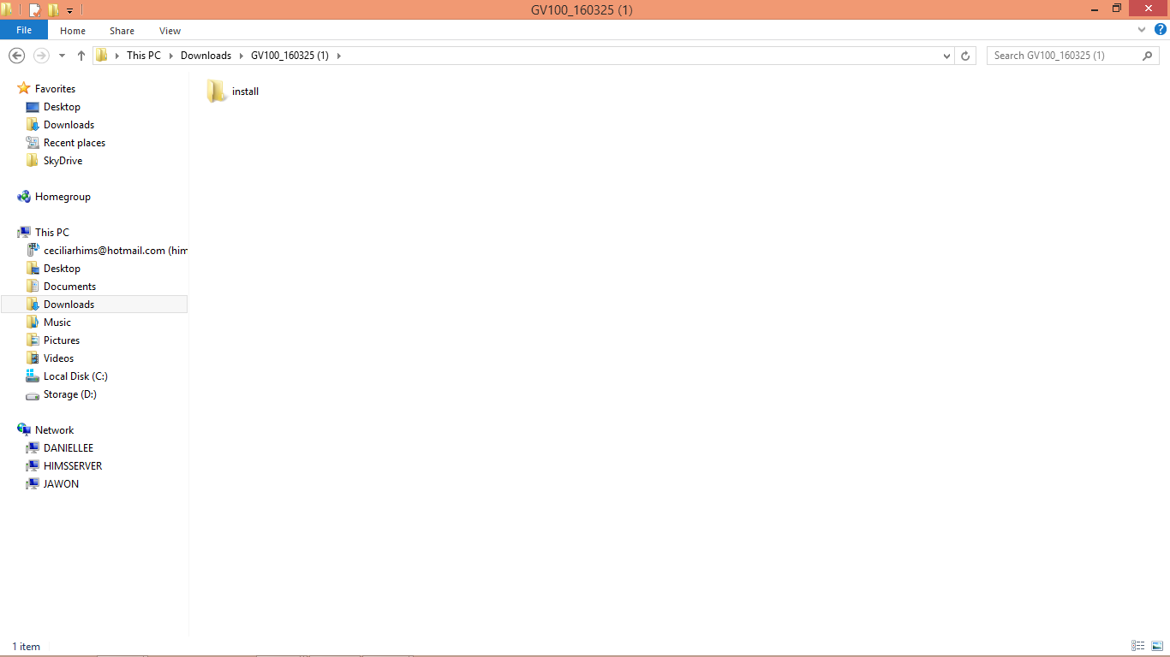

2. If you complete the copy to a USB drive, then please insert the USB drive to the USB port of GoVision. A dialogue pop-up window which ask whether you want to upgrade will be displayed if the USB drive is recognized by GoVision.
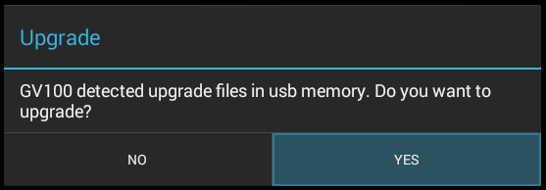
3. If you select YES, then it starts to copy the firmware file from the USB drive to GoVision. Please do not remove the USB drive from GoVision or do not turn off the GoVision while the copy is in progress. It can make critical issue if you remove USB drive or turn off the GoVision while the copy is in progress.
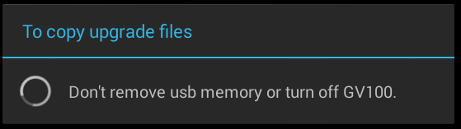

4. If the copy is completed, then it asks you whether you want to delete the upgrade firmware file from the USB drive. If you do not have any other GoVision units to upgrade, then please select YES to the firmware folder/file from the USB drive.
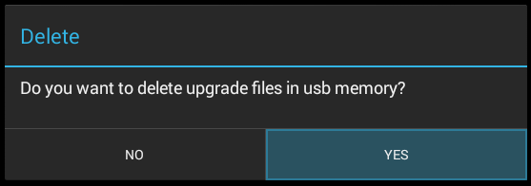

5. If you select YES, then the GoVision unit is turned off by itself in several seconds. After that, please turn on the GoVision by pressing the power button again. In this case, it will take longer time than normal booting as the GoVision is internally installing the new firmware. Please do not turn off the GoVision until the booting is completed. It can make critical issue if you turn off the GoVision while the booting is in progress.

6. If the booting is completed, then please make sure the latest firmware version was successfully installed. You can check it by following the menu as below.
MENU -> Advanced Options -> Product Information
